PROJECT REPORT TEMPLATE

INTRIDUCTION

OVERVIEW

Keerthi Sweets a Manufacturer and Trader of Sweets, relies on Zoho Books to manage their inventory, handle purchase orders, and generate invoices for their customers. They can track stock levels, manage supplier payments, and generate financial reports. Zoho Books helps them streamline their wholesale operations and optimize inventory management.

PURPOSE

The purpose of Keerthi Sweets is a renowned manufacturer and trader of delectable sweets, catering to both wholesale and retail customers. With a rich heritage spanning several decades, Keerthi Sweets has earned a reputation for its commitment to quality, authenticity, and customer satisfaction. Specializing in a wide variety of traditional and innovative sweets, they combine traditional recipes with modern techniques to create flavors that tantalize taste buds.

EMPATHY MAP

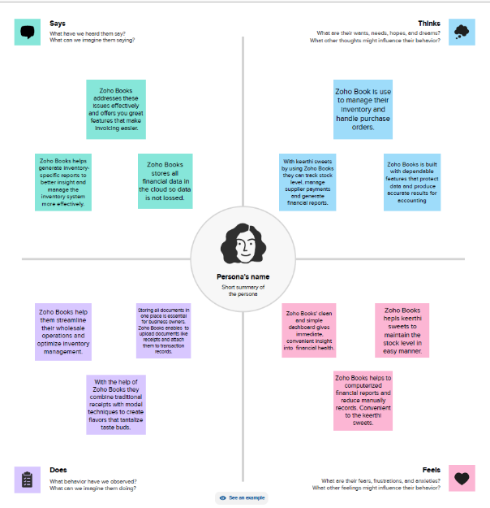

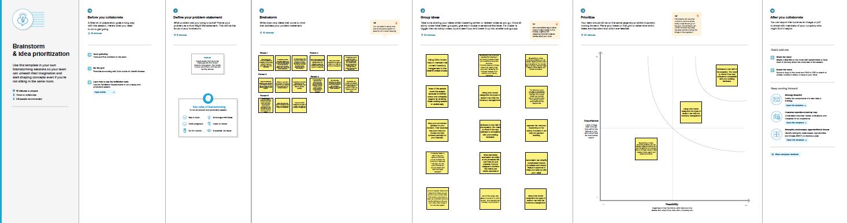IDEATION & BRAINSTORMING MAP

RESULT

PROFIT AND LOSS AC

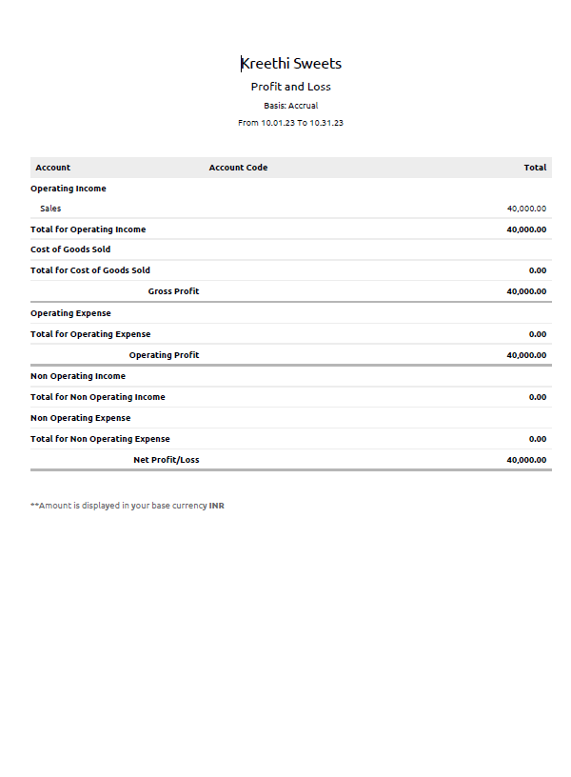

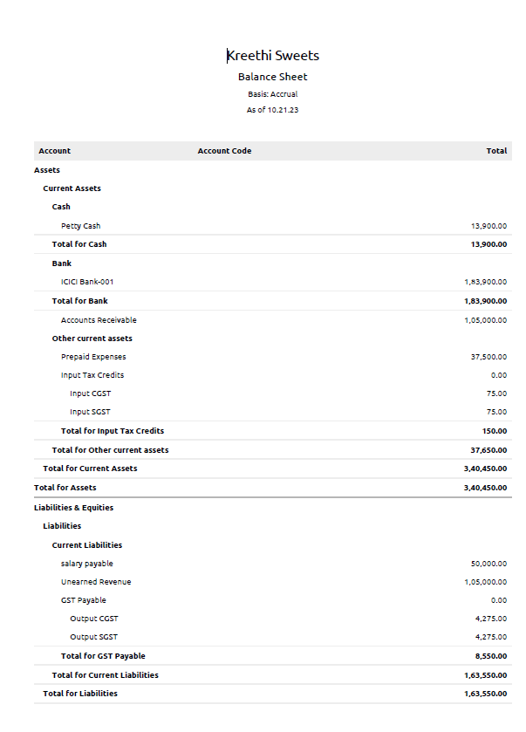BALANCE SHEET

ADVANTAGE AND DISADVANTAGE

Pros

* Zoho books features entry-level software that can grow with your business.
* Intuitive and easy to use the platform features a straight forward dashboard and versatile, multifunctional client portal.
* Zoho books offers an affordable pricing plan with options designed for microbusinesses.

Cons

* There is a cap on your monthly invoices, which may become an issue for growing businesses.
* Zoho books lacks tools for calculating quarterly tax and other key business tax calculations. Its primary tax focus is on sales tax.
* The audit trial tool isn’t available to customers in the U.S. or Canada. It is only available to users in the U.K., Europe, and a few other countries.

APPLICATIONS

We have used this applications to the area of this solution can be applied in mural, zoho books and github.

1. First step of any data analytics project is to frame a comprehendible problem statement.

2. Data collection and preparation.

3. Exploratory data analysis. (Exploring the data visually )

4. Model Building and testing. (These models must be tested and validated to ensure accuracy and reliability )

CONCLUSION

This project is useful to understand the accounting software zoho books for Travel Trax Tours. This project steps is little complicated to understand.

FUTURE SCOPE

Continuous learning and improvement ensure that the data analytics project results are credible and all necessary changes to improve the accuracy and relevance of the insights are taken into accounts.

Good communicating ensures that each team member knows the project goals and expectations and can pass on the project finding to all technical and non-technical stakeholders.

Fostering an environment of collaboration and alignment among the team members and different teams sets the project on a successful track. This is because different teams and individuals bring different skills and perspectives to the table resulting in a more diverse and complete analysis.

APPENDIX

A. Source code

This is my source code that I uploaded in github.

https://github.com/Raji1515/keerthi_sweets_NM2023TMID10902